FAMILY CARE FOR CHILDREN (FCC Rwanda)
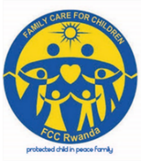
Eastern Province- Gatsibo District TEL: (250) 0788726245 or 0784453372
E-mail: familycareforchildren@gmail.com
Website: www.fccrwanda.org.rw

ANNUAL REPORT 2017-2018
- Training of street children and their parents on child rights and protection
On 10th December 2017 in Kiramuruzi sector of Gatsibo district, Family Care for Children (FCC) had trained twenty three street children (23) and their sixteen parents(16) from Kiramuruzi andKizigurosectors; and the training had taken place in BLUESKY MOTEL.
I.a. Objectives of the training:
- To improve skills of street children on child rights and child responsibilities
- To increase mindset of parents on child protection
- Mobilizing Street children to rejoin their families
- To remind parents their responsibilities of caring their children into families and to prevent family conflict.
- To know children who have parents and who have not, and finding exactly where they curently live
- To identify true reasons why children leaft their families to join street life
- To find the exact number of children who live in the street, grouping them according to age; in order to help them to leave this dreadful street life
- Planning the manner how they would rejoin schools in the academic year 2018.

I.b. The main reason why of the training indeed:
Family Care for Children (FCC) had an intention and wide to gain the exact information about street children and their parents so that FCC achieve its objective for returning back street children to their families by appointing much on the prevention to new street children. In addition, we, FCChave in need to find who could gather direct support among those beneficiaries, according to their state of life at home, especially their source of incomes.
Children were made into diverse groups according to their age: from 9-12; and 13-17, by picking out reasons which have pushed them to live onto the street.
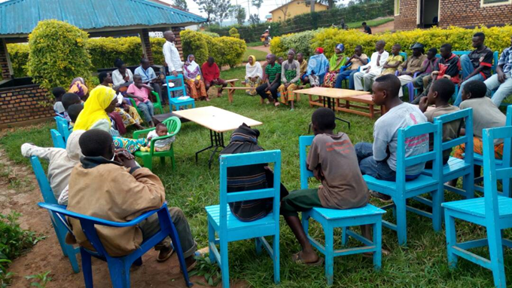
Parents and Street Children set together in the training.
Children had exhibited the following causes:
- Their fathers who quite homes and make away the children
- The misunderstanding of parents into the family, the example of wifes who welcome men at homes on absence of fathers, and vice versa
- Being beaten act by parents who became beer drunkards
- To make children in excessive and very hard works not matching to their age
- Food carrency into diverse homes especially when the children come to school
- To be orphan
- Poverty into their families.
Exhibited causes up to the parents:
On their side, parents into diverse groups had given the causes which make their children to live onto the street in case they know and see. After being questionedthemselvesthey had given the following causes:
- The less capacity of families for fulfilling their children’ needs
- Joining indiscipline children’ groups by themselves
- The generally need of children for liking the easiest life non-favorable to them
- Children’s disliking punishments when they have mistaken
- Some parents who do not happen their duties and have not parental love to their children
- Missing occasion to converse with the children into their family where their could learn values, plus the cleanliness
- Giving hard responsibilities, not matching to their age.

I.c. We afterwards took an opportunity for giving suggestions and wishes of what to do so that children come back to their families from street:

The needs of children:
- We want to go back at school in case we can get food and clothes
- Mobilising those children to join Technical schools
- Being given convenable help especially in paying Health Assurance (Mituelle de Santé) and other diverse needs at home
- Mobilising our parents not to be beer drunkards, so that they let unreal culture for welcoming new men and women into our homes while they give us dictatorial tasks at home
- To get families who can educate us and make us to be back at school
- Being put into centers where we can get behaviours’ correction and change.

The needs of parents:
- Helping us to put our children into Centers where they can get behaviours’ correction and culture for they are actually living in abnormal life conditions
- To punish as real the owners of wagon restaurants and Bars who engage them to do hard works and pay them food and drinks as rewards
- Helping the poor families to get their true Social Class so that the government support reaches them as well.
- Mobilising parents to have in their daily duties to prevent new street children
- Helping us to mobilize our mature children to join the very far Technical Schools and coming back after finishing their technical studies
- Helping us to make a good understanding to our children for going back to their families, going at school and being satisfied in the dispatch of few family products as their capacity is, the state of families in general.
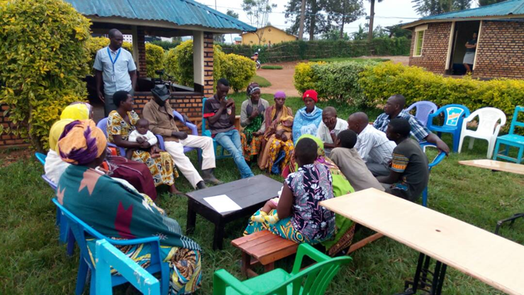
Parents giving their suggestions about this children’s issue
I.d.Appointed Tasks by Family Care for Children together with Parents and Children after being counseled at the end of the above training:
- To link orphan children to the the local leaders so that they be allowed the particular and direct support
- Attending to meetings with businessmen particularly the owners of Restaurents and Bars in order to have adequate solution to the existing querry
- To help children to rejoin the school from 2018 hand in hands with the Local Leaders, parents and school leaders; and punishing whoever refuting this
- Taking street children who did not change their mind set refuted to be back into their families; so that they be into diverse Centers where they will get behavior changeand culture plus values.
- Every parent has to give information about his/her children who have intention to be new street child.
- In January every street child must be back at home in partnership with schools and parents in direction by Family care for children and Local leaders.

THE TABLE OF CHILDREN WHO EDUCATE THEMSELVES AT HOME
No | NAMES | CAUSES
1 | TUYIZERE BUSSEN | His father isn’t yet alive, and her mother is into prison for selling non-allowed and irregal beer
2 | HAKIZIMANA Elisa | His parents made him away from while he was still a baby
3 | NIZEYIMANA Jean Damour | His parents made him away and he continued living alone.

THE TABLE OF FULL ORPHAN CHILDREN
No | NAMES | STATE
1 | RUCYAMUZI Elisa | All his both parents are not still alive.

THE TABLE OF STREET CHILDREN ACCORDING TO AGE
No | Age | Number of children
1 | 09-12 | 13
2 | 13-17 | 10

Children who leaft street life by FCC ahead:
1. MURENGEZI Kazungu
2. KWIZERA Emmanuel
3. HABIMANA Emmanuel Kadugara
NB:The above street children who exited street life accept to be received and cared by diverse Rwandan families in case they have ability to do so. This was their first step they did and there would be made the second step for rejoining their own families and the third for going back to school.
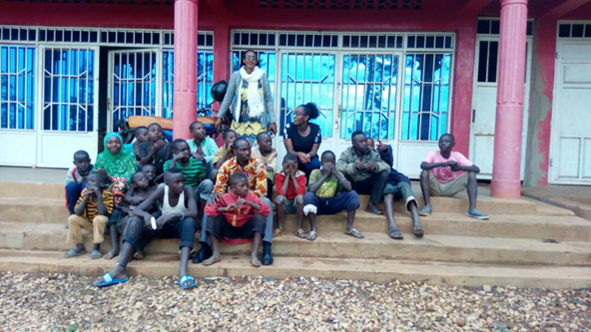
Children from streetofKiramuruzi and Kiziguro Centers together with FCC staff.

- Achievement and support provided by FCC
In January 2018, FCC organized the meeting with Local Leaders, Parents, Children still live in street, businessmen and teachers in discussion about following issues:
- To know the reasons why children decided to leave their families and living onto the street
- Researching families within those children came from
- To unit children and parents so that we remind both parties via their duties into the family
- Preparing whatever mechanism to return all children at school in the academic year 2018.
II.a. Realized activities:
*To rescue children from the street to families in partnership with their parents
*Prevention of new street children in partnership with citizens in villages and the Local Leaders
*Doing advocacy for poor families, who have children droped out to be street children so that they get school materials and returned to school by health and social protection officer.
* The members ofFCC in partnership with local learders went in all villages, where the street children came fromin order to search for their families and most of them were found; so that they work together with FCC in returning those children into families to be cared as real as Rwandan child.
* 9 children of those who came from street are still studying and monitored by FCC
* Family Care for Children have created children’s groups of Child rights and Protection called “Cared Children Clubs” (CCCs) includes children from street and other from community
*12 parents, 2 per children’s group (1 famale and 1 male)as parent mentors are trained on UNCRC, ICRP, LAW N°71/2018 OF 31/08/2018 RELATING TO THE PROTECTION OF THE CHILD. Will support children on advocacy of their issues, mediation with parents and child care.

II.b. Children were given diverse materials
After the training indeed, FCC analysed to find who could be given direct support among those children andwe supported them in the following:
- Children were given new note books and pens to use in next new academic year
- Children were given shoes while they were using feet which caused most of them diverse feet and skin’s sicknesses
- The children were bought soaps so that they control cleanliness of their body skin and clothes.

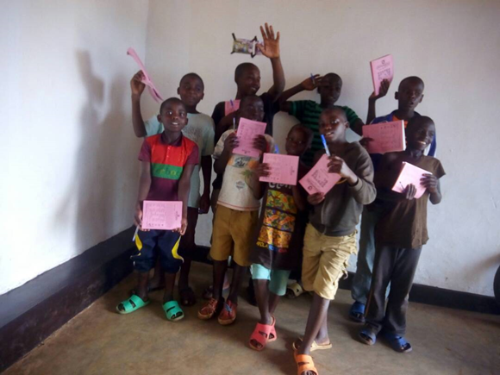
These 9 children were street children now are still studying through FCC support of school materials
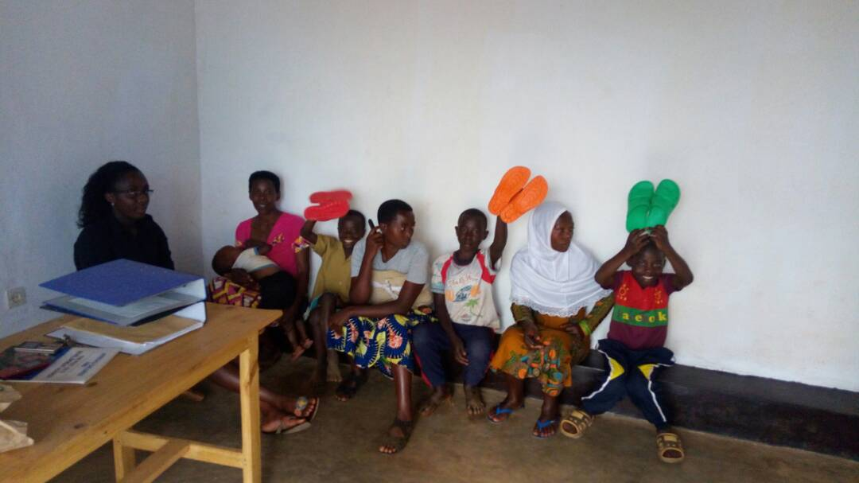
Children were got support of shoes

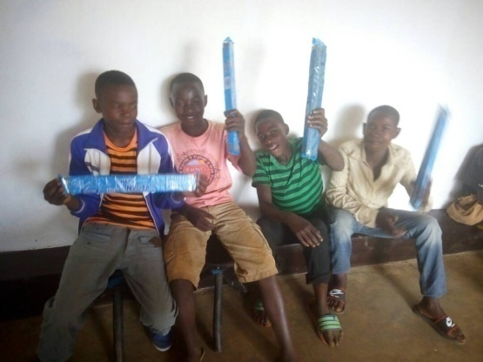
Children were got support of soaps

II.c. The conference made on issues affecting children in Kiramuruzi and Kiziguro

After observation of many issues affecting children in our intervention area, FCC organized the big meeting includes community leaders, civil society organs, NGOs, teachers, child care givers, community health workers, businessmen, parents and children. The objective was to discuss together what we can do about children’s issue in this zone and taking the mitigation measures.
Many ideas were given but one of them is creation of Community Social welfare and Child Protection Mechanism (CSCPM), will gatherd teachers, inshutiz’umuryango, parent committees and GBV committees.
Hussein is businessman and citizen ofKiramuruzi sector in Gakenke cell, is a good partnerin solving the above issue, while he has two children who were living onto the street at his home. He said "Truly these children living onto the street are all for us, Rwandans and their education is the duty of ours. For me, it is hard while I rescue them from the street; this makes me not to accomplish well my existing daily duties and responsibilitiesthat is why I want their parents to remember the duties and responsibilities to their children, one of them is caring them into their families."Hussein said.

Astheria, a citizen of Kiziguro sector in Rubona cell is a commissor of National Human Rights Commission in charge of Children."We willingly neglected our parental duties and responsibilities, that’s why for result our children became a hard task to us, we need to improve the mechanism we follow up prevention to inconveniences of this existing issue, in partnership with all concerned people."Astheria said.

Maitre Alinestaff of WORLD VISION participated in the meeting her suggestion is"The parental love and care were not there and it is the main source of all inconveniences we are facing to, now: violence of Children’s rights into families, drug abuse and more others due to the non-achievement of duties and responsibilities; the non-love and misunderstanding between children and the parents. As result, children took unpreasent decisions."Aline said.
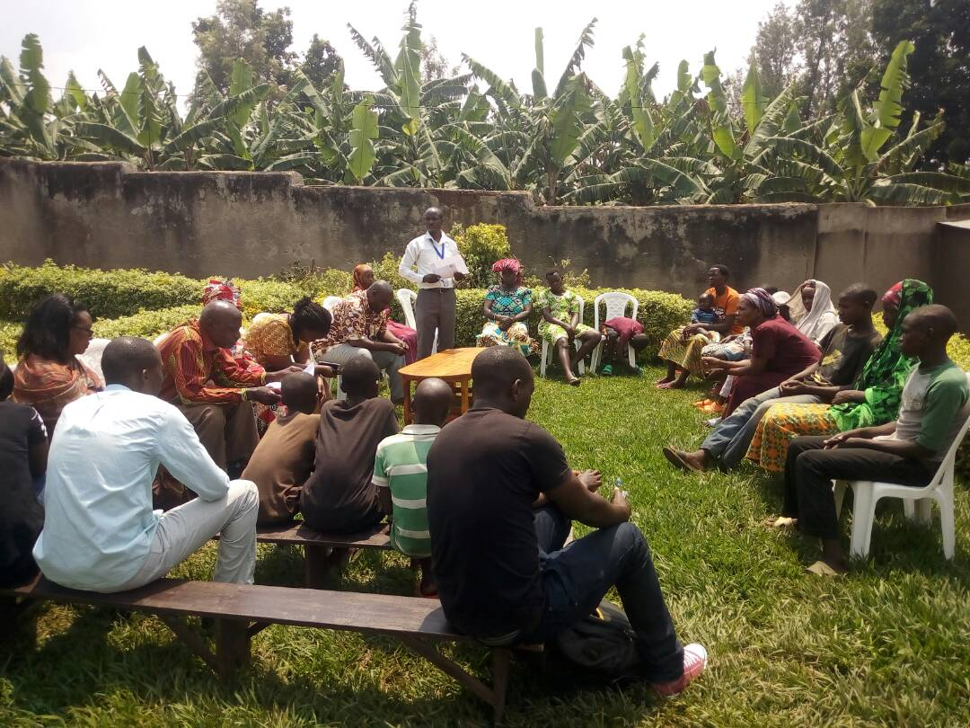
Conference with stakeholders on the issue affecting children in Kiramuruzi
II.d. Children had been back into families and went back to school
Among 24Children who were living onto the street fromKiramuruziandKiziguro sectors, 17 are back to school by FCC effort but 9children are now studying and are in their own families and 3among them were adopted in diverse familieswithin there are actually getting education. Are studying in G.S. Gakenke, MORDERN SCHOOL KIRAMURUZI, and BRIGHT ACADEMY Kiramuruzi.

- children’s contribution in the existing issue
Family Care for Children (FCC) formed diverse clubs of children into cells of the two sectors at the beginning, Kiramuruzi and Kiziguro; and which usually works in partnership with leaders in cell and sector.
III.a. Responsibilities to Clubs of children:
- Meeting themselves to revise their rights, responsibilities and sharing information of social welfare of the child into families
- Doing advocacy to other children who are facing violence to their parent mentors
- To exhibit their contribution in all that the government planed for them
- Teaching themselves about having good behaviours
- Practicing their talents
- Organizing community campaigns on child rights promotion and protection
NB: Those Clubs of children have usual 2 parents in charge, who control their activities, hearing them for their challenges.
III.b. Achievements of those clubs
      - They did mobilization on fighting aginst violence which faces children into diverse families and reminding parents to happen their duties and responsibilities. The mobilization indeed was done by GIRUBUZIMAMWANA CLUB of GakenkeCell inKiramuruzi sector.
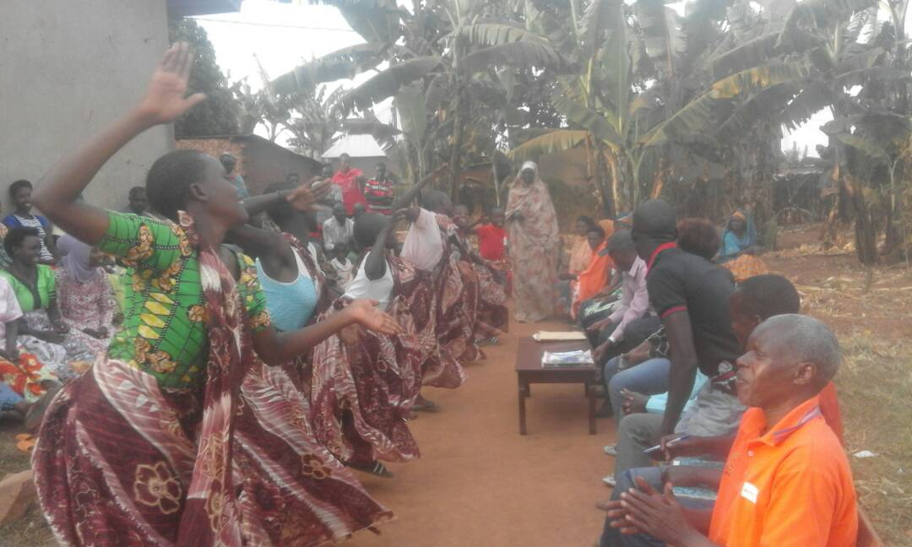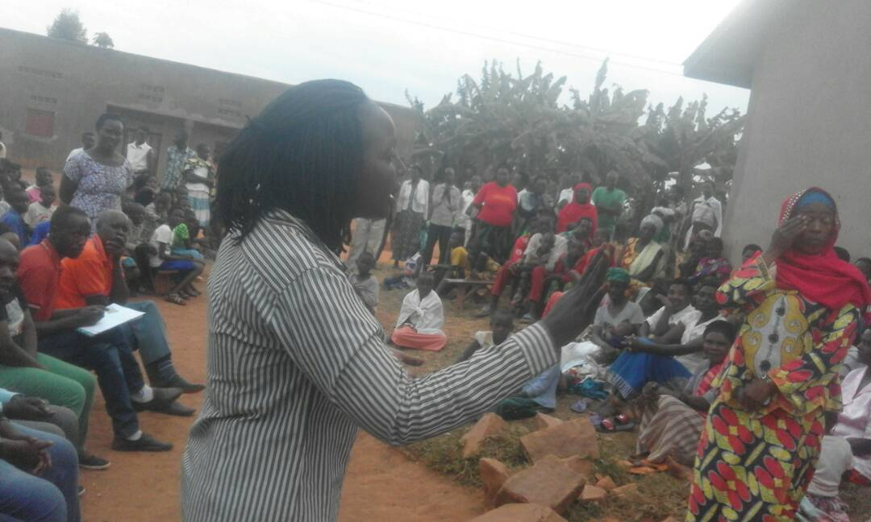
GIRUBUZIMAMWANA Club welcoming guests, the Executive of Kiramuruzi Sector ahead

      - There was done mobilization on child rights, in prevention of any violence by revising all duties and responsibilities to be followed up. This was done in Akabuga Cell of Kiramuruzi Sector, and this was done via children’s groups formed by FCC to facilitate the mobilization; where by the invited honorable guest was the Sector employee in charge of Social Affaires in Kiramuruzi.
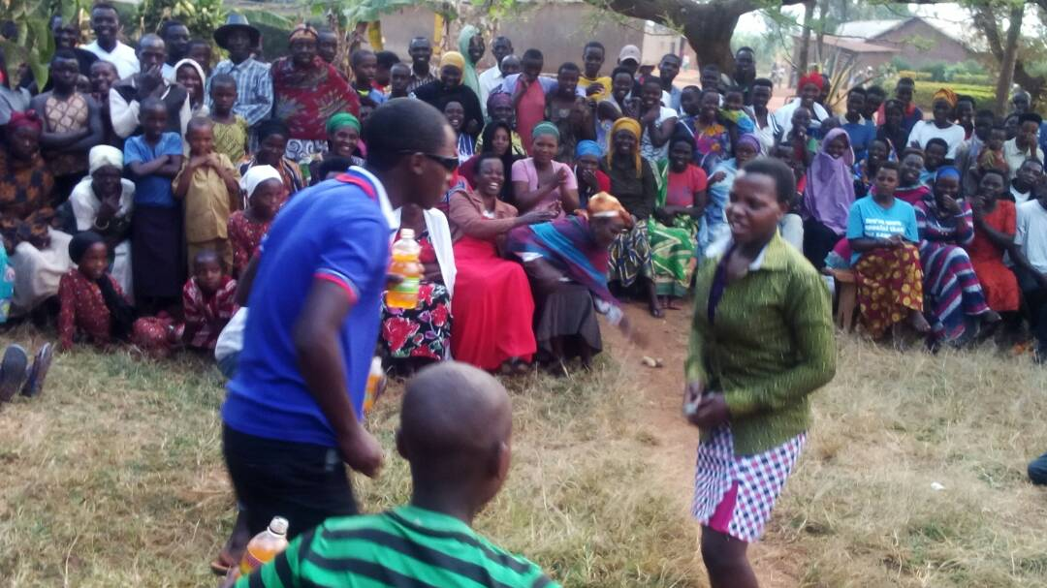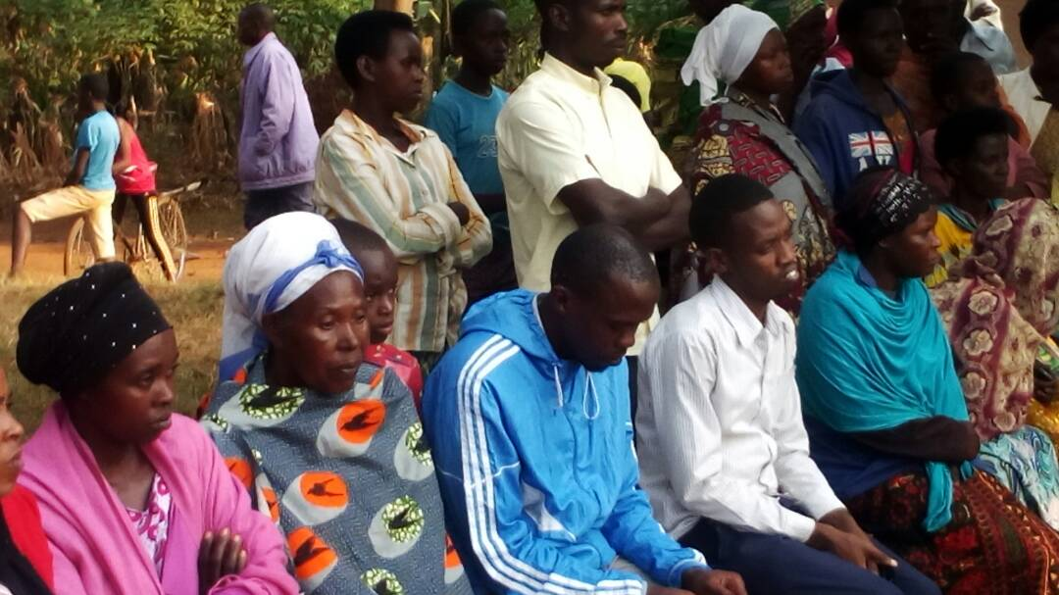
Photos showing Children in a Play mobilizing parents to revise Children’s Rights and the prevention of quantitive and very hard works to them
      - The campaign of to remind parents that Education is one among the rights of a child, their duties and responsibilities in particural. This was done in partnership with a Cell, Children’s club, citizens and Local Learders.

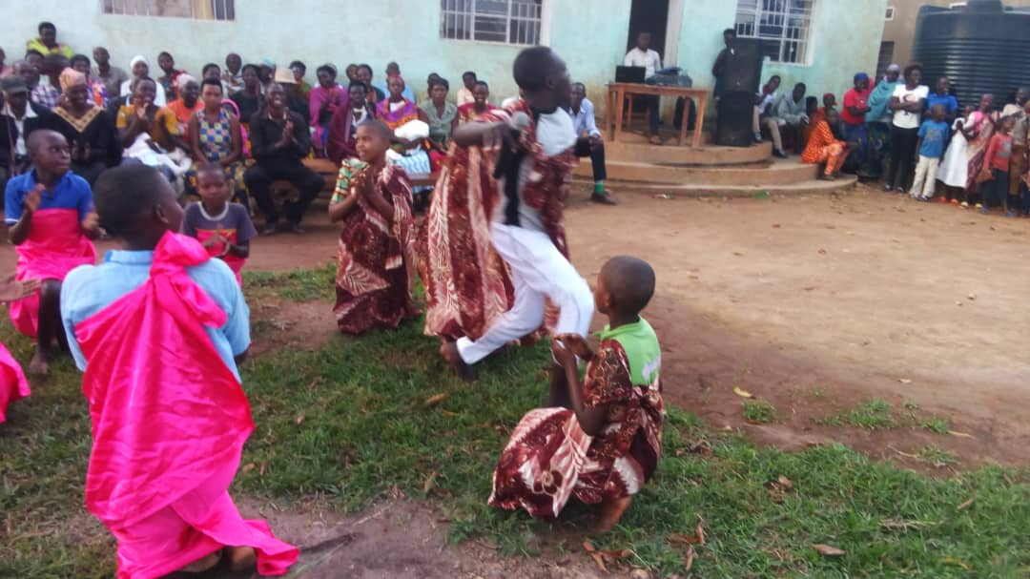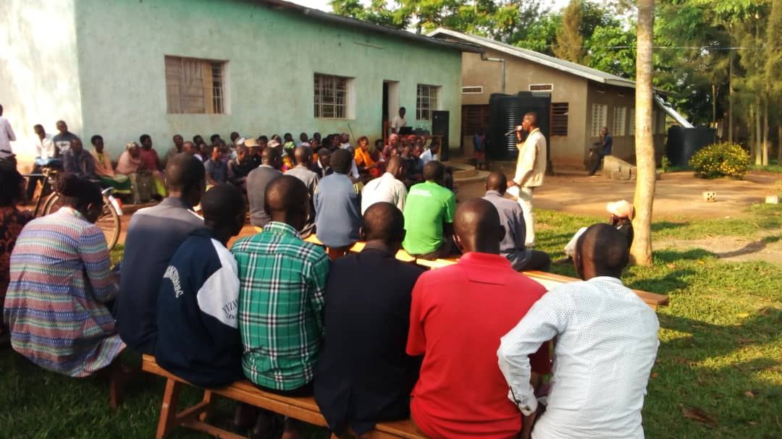
Photos of Mobilisation in Nyabisindu Cell of Kiramuruzi Sector

- Participation
Children are the main actors in general where they identify issues they need to advocate for. In this year they participated in many campaigns of various messages and different meetings. They leading different child rights promotion and advocacy initiatives at grassroots and Districts levels.
IV.a. Inclusion and non-discrimination: FCC has facilitated Children’s groups with inclusion and non-discrimination to promote the government vision on promotion of living in inclusive society. As a result children with disabilities and others vulnerable children are involved in all activities. In fact, all children are provided with opportunities to participate actively.
IV.b. Gender equality: As it our value, in all activities we involve both boys and girls children also females and males adults. The events organized are gender sensitive as indicated in statistics of attendance reports.
IV.c. Conflict: FCC is being implement in a safe and favorable environment and involving both beneficiaries, stakeholders and local authorities with conflict management mechanism.
IV.d. Risk Management: FCC have child protection risk assessment document, for assessing and manage the situation, space or site of activity involving children if is safe and if can protect children.
IV.e. Monitoring and evaluation: F.C.C work hand in hand with other NGOs and local leaders to develop a comprehensive M&E Plan and it is being used as a guiding M&E document.FCCalso developed its own tools that helps into data collection of field activities.
- Lessons learned
V.a.Sustainability: FCC mainlysupports the establishment and strengthening independent children’s groups for advocacy in operational district and these are the engine of the sustainability component. Also local leaders are sensitized and trained on child rights, protection and participation and are actively involved. Children are motivated to advocate for other children though some cases are still not addressed. The current initiatives and achievements by children in their communities also confirm the sustainability of the project activities.
Children are able to support and advocate and they are able to find solutions themselves whenever they are given opportunity. The best thing to do for them is to give them space and time to voice out their problems, show them their potential and support them in their initiatives they can achieve more whenever they know that there is someone there to advise and to listen to them.
V.b. Effectiveness: Cared Children Clubs are actively collaborating to support the vulnerable children through advocacy but they need more support to implement the planned activities. Children are self-confident to express themselves through trinings gained in fronts of adults and leaders without fear and children are also thinking about other children out of the program.
V.c. Efficiency: The implementation of these activities considers the field reality and tries as much as possible to minimise costs and volunteer works with high level achievement of the results.
- Challenges FCC faced are following:
- Children who want to quite street life but do not have families to be received by for they are orphans, families who changed residence to unknown local places
- Unsufficient school needs like uniforms and school materials in general
- Children who leaft streets and want to learn in technical schools while they do not have financial ability
- Children who do not have Health Assurance (Mutuelle de santé)
- Missing families of those children, their current residence in the time we were inviting them to conference and training
- Children had fear for the attendance to conference and training that they could be prisoned by Police
- Parents refuted attending to the conference and training although they had invitations
- Parents who do not like their children to come back at home due to diverse familial conflicts between children and their parents
- Children who do not accept going back normal schools but liking the technical schools whilst they do not know reading and writing.
SUCCESS STORIES
Among 24 Children who were living onto the street from Kiramuruzi and Kiziguro sectors, 17 are back to school by FCC effort but 9 children are now studying and are in their own families and 3 among them were adopted in diverse families within there are actually getting education. Are studying in G.S. Gakenke, MORDERN SCHOOL KIRAMURUZI, and BRIGHT ACADEMY Kiramuruzi.
RECOMMENDATION
Local leaders, businessmen and parents need more child rights trainings and tools and materials like CRC, ICRP, CHILD PROTECTION POLICY and Child protection law N°70/2018 of 31/08/2018
CONCLUSION
FCC came to achieve all above objectives, we appreciate and thank all Partners:Gatsibo District,Kiramuruzi andKiziguro Sectors, beneficiaries (Children) and Parents; particurally Families who accepted and adopted some street children, who ere not theirs. We appointively thank you all for a good partnership targeting to the welfare and wellbeing of theirs.
FCC shall continue to support children, parents and community for promoting child rights, protection and participation and well being of Rwandan children in partnership with diffent institutions.

GAKWAYA J.M.Vianney
Programs Manager
Family Care for Chidren


