FAMILY CARE FOR CHILDREN (FCC Rwanda)
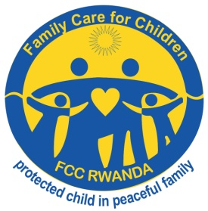
Eastern Province- Gatsibo District
TEL: (+250) 0788726245 or (+250)784453372
E-mail: familycareforchildren@gmail.com
Website: www.fccrwanda.org.rw

ANNUAL REPORT 2020-2021
- Family Care for Children Background
Family Care for Children (FCC Rwanda) is Rwandan non-profit organization which privately focuses on the promotion of rights, protection and participation of the children/youth under less than 25 years whereby those are roots of better future of the country. Is a Non- Governmental Organization, registered with Rwanda Governance Board with Certificate of Legal Personality: NO 652/ RGB/NGO/LP: 09/2020.
It was established in July 2017 with vision of to have a social welfare and well-being of the child/youth within a family this fully respects Child Rights, mission of to protect the Child/Youth, advocate the issues affecting them, Improve the mindset of the community on Child Participation and Capacity building in child rights. Its values are child interests, gender equality and non discrimination.
The objectives of FCC Rwanda are to Support children, parents and community in promotion of social welfare and well-being of the child/youth and full respect of child participation and protection policies;
Promote and arise national consciousness for the respect of child rights, as defined in the United Nations Convention on Rights of the Child (UNCRC);
Advocate issues affecting children/youth to the local and national institutions and Undertake researches in the field of child rights, protection and participation
The FCC’s areas of intervention are Education for eradication of school dropout and positive parenting; Health for sexual reproductive health, hygiene and sanitation; and
Youth empowerment for capacity building on youth opportunity and youth development projects
- Achievements and realized activities
II.1. Training of children’s committees of child protection clubs on child rights/protection and participation
On 11th to 12th August 2020 in Kiramuruzi sector of Gatsibo district, Family Care for Children (FCC) had trained fourty children (40) 26 girls and 14 boys from Kiramuruzi and Kiziguro sectors; and the training had taken place in the conference hall of FCC Rwanda for two days.
II.1.a. Objectives of the training:
- To improve mindset and skills of project beneficiaries on child rights/protection and child responsibilities
- To guide children’s committees to mobilize street children to rejoin their families or caregivers
- To improve skills of identifying, reporting and advocating the issues affecting children in the families and communities.
- Planning, networking and collaboration with local leaders and other institutions working on child rights.
These children were trained on child protection law, integrated child rights policy (ICRP), United Nation Convention of Rights of the Child (UNCRC) and African Charter on the Rights and Welfare of the Child (ACRWC)
II.1.b. Time was given to the children to present the issues affecting them and causes:
- Their fathers who leave homes and make away their children
- Being beaten actions by parents who became beer drunkards
- To make children in excessive and very hard works not matching to their age
- Food carrency into diverse homes especially when children come to school
- To be orphan and children headed households
- Child labor and exploitation by their families and community
- Family conflict between parents
- Poverty into their families
- No children’s participation in family decisions and plans or missing occasion to converse with the children into their families.
We afterwards took an opportunity for giving suggestions; participated children gave the recommandations and wishes of what to do so that children can be protected and wellbeing:
- They want to study in good conditions and stay in schools in case the issue of school feeding program can be resolved between parents and schools management.
- Supporting children who are not able to continue the ordinary school but need to join technical schools
- Being given convenable help especially in paying Health Assurance (Mituelle de Santé) and other diverse needs at home
- Mobilising parents for having a positive parenting and not to be beer drunkards, so that they let unreal culture for welcoming new men and women into our homes while they give us dictatorial tasks at home
- Helping the poor families through income generating activities so that children can enjoy the social welfare
- Mobilize community leaders to prevent and to take mitigation measures about violence against children in the community and punishing who usually doing it especially businessmen, motorcycle transportors and teachers
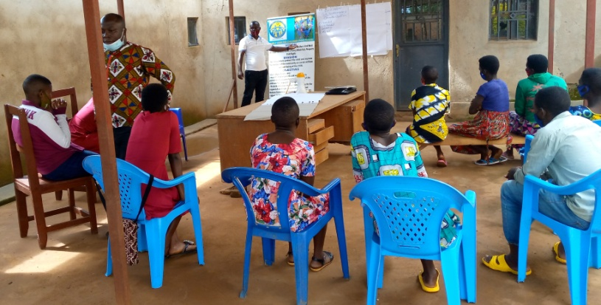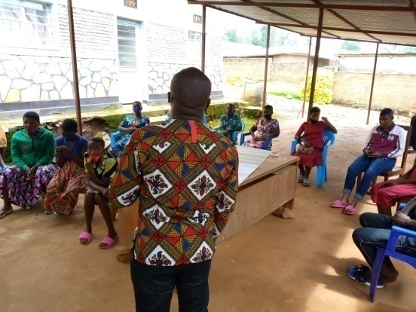
Children’s committees in the training with FCC facilitators
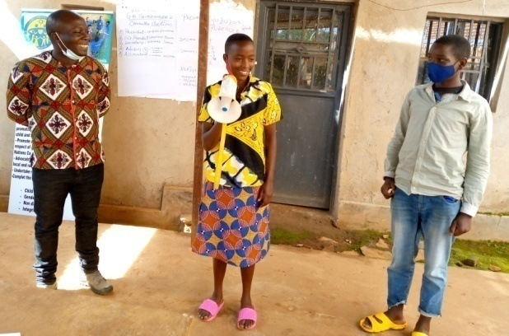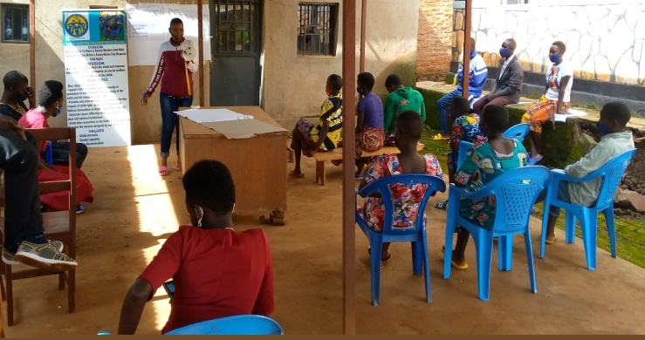
Children in execise of community mobilization on child protection using mobile microphone. The second pictures one of the participants are presenting the issues affecting them in the community
II.2. Community meeting on children’s issues
In July 2020, FCC organized the meeting with Local Leaders, Parents, businessmen and teachers in discussion about child protection issues and other issues affecting children of Kiramuruzi community:
- To know the reasons why children decided to leave their families and become street in this community
- Researching families within those children came from
- To unit children and parents so that we remind both parties via their duties into the family
- Preparing whatever mechanism to return all children at school in the academic year 2021
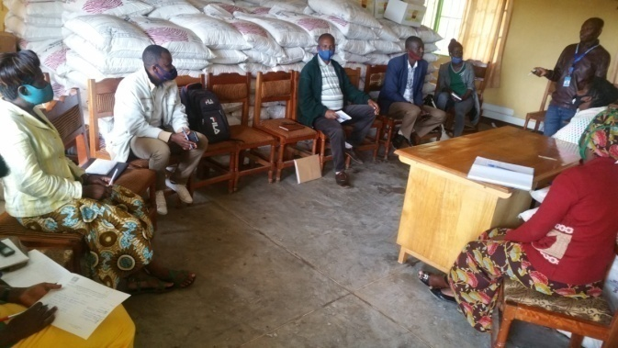
Meeting with Local Leaders, Parents, businessmen and teachers in discussion about child protection issues and other issues affecting children
II.2. a. success story for child protection:
One child explained that he decided to be a street children because he was not confortable in smallest house of one room he live with 8 family members where he was sleping with 5 siblings, this family was supported by FCC members a big house of three rooms with kichen and toilet outside.
New house built by FCC Rwanda and the old one
II.3. Conduct a Training of Trainers (ToT) for members of National Youth Council at the sector level on Sexual and Reproductive Health (SRH)
In July 2021, the committees of national youth council at sector level were selected to be trained for three days on sexual and reproductive health for purpose of to train other youth, children and community on this training. The objectives of this training were achieved by the trained following topics:
- Sexual and reproductive health and rights in general
- Family planning for youth its methods, effects and availability
- Prevention of early pregnancies and child care before birth
- Protection of teen mothers and their children
- Methodology for training those topics
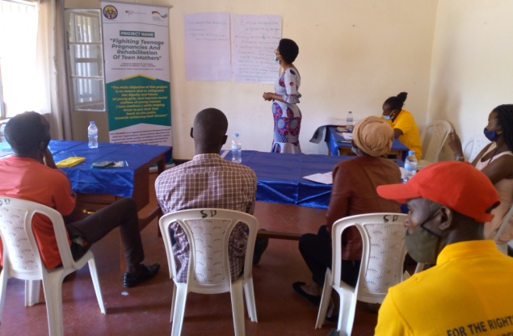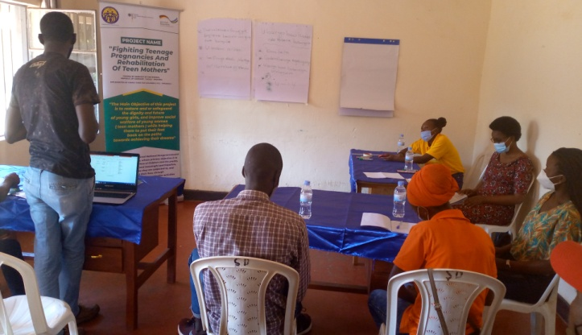
Youth committees were trained on sexual and reproductive health and rights
II.4. Conduct a sensitization campaign in 5 secondary schools targeting teenage boys mainly and girls on abstinence till marriage and change of sexual behavior at school and in their communities
From January to February 2021, FCC Rwanda organized the activity of sensitization in three schools targeting teen boys mainly and girls on abstinence till marriage and to change sexual behavior at school and in their communities. This activity was implemented in partnership with local leaders from district to Cell level and with school authorities.
The head teachers of Groupe Scolaire Kiziguro, Nyabisindu, and Adventist Polytechnic School, director of good governance in the district, gender officer, sector education inspector, FCC staff and youth committee trained on SRH were provided the advice and discussed with 2,186 students’ boys and girls studying in the schools mentioned above, on the following topics:
- Reproductive health
- Sexual reproductive health and rights
- Abstinence till marriage
- Sexual behavior change
- Sexual deseases, STIs and HIV/AIDS
- Fighting early pregnancies together boys and girls as barrier of the future etc…
II.4.a. Recommandations of students after conversations with authorities on those topics:
- To improve education program in schools regarding to teach sexual and human reproductive health
- To sensitize biological parent or guardian to discuss with their children about human reproductive health
- To provide good services related to human and sexual reproductive health especially conseling to the victims on sexual abuse
- To train on a regular basis health professionals, community health workers, teachers, authorities of decentralized administrative entities, the private sector and the youth on human reproductive health and sexual reproductive health and rights
- To punish some teachers who disturb girls for purpose of sexual relations
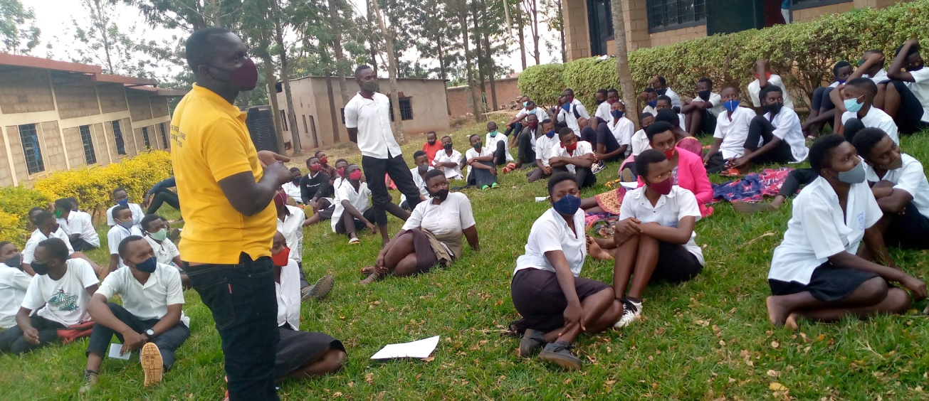
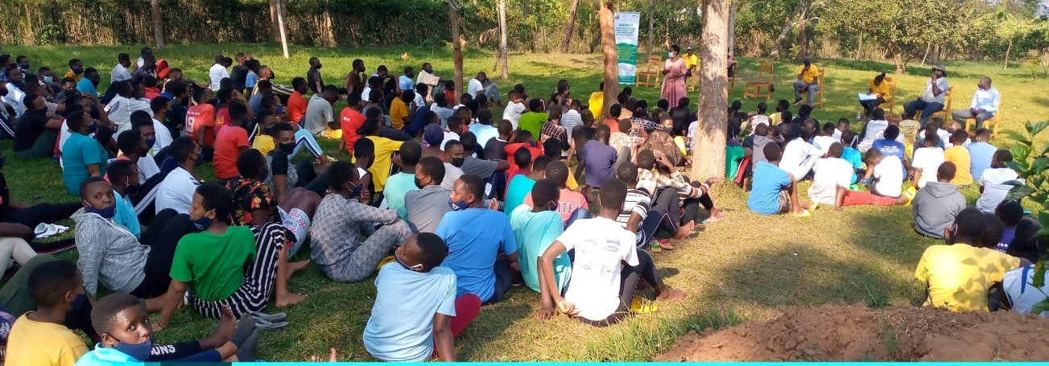
Campaigns conducted in GS Kiziguro and Nyabisindu
II.5. Establishment of two listening points into 2 sectors where teenagers can come and call to seek support and guidance
This activity is implemented from June 2021 and funded by the German Embassy in the Fighiting Teenage Pregnancies and Rehabilitation of Teen Mathers project. The FCC has set two sites, one in KiZIGURO and the other in Kiramuruzi.
Two staff members have been appointed to address the issues of abuse and to provide counseling, advocacy to ensure that the victims of the violence are punished or compensated.
In only two months from the bigining of this activity 44 cases were received and oriented to the partners institutions responsible of violence in its attribution.
- Participation
Children are the main actors in general where they identify issues they need to advocate for. In this year they attended compaign and participated in giving their opinions and various messages in the trainings and meetings. They leading different child rights promotion and advocacy initiatives at grassroots and Districts levels.
III.a. Inclusion and non-discrimination: FCC has facilitated Children’s groups with inclusion and non-discrimination to promote the government vision on promotion of living in inclusive society as our vision. As a result children and youth with disabilities and others who are vulnerable are involved in all activities. In fact, all are provided with opportunities to participate actively.
III.b. Gender equality: As it our value, in all activities we involve both boys and girls children also females and males adults. The events organized are gender sensitive as indicated in statistics of attendance reports.
III.c. Risk Management: FCC have child protection risk assessment document, for assessing and manage the situation, space or site of activity involving children if is safe and if can protect children. The trainings, campaigns and meetings were conducted in compliance with the COVID-19 prevention protocol to ensure the safety of the involved participants.

III.d. Monitoring and evaluation: F.C.C work hand in hand with other NGOs and local leaders to develop a comprehensive M&E Plan and it is being used as a guiding M&E document. FCC also developed its own tools that help into data collection of field activities.
- Lessons learned
IV.a. Sustainability: FCC mainly supports the establishment and strengthening independent children’s groups for advocacy in operational districts and these are the engine of the sustainability component. Also local leaders are committed to support the FCC’s activities because are the responses of youth and children’s issues and are actively involved. Children are motivated to advocate for other children though some cases are still not addressed. Children and youth are able to support and advocate and they are able to find solutions themselves whenever they are given opportunity. The best thing to do for them is to give them space and time to voice out their problems, show them their potential and support them in their initiatives they can achieve more whenever they know that there is someone there to advise and to listen to them.
IV.b. Effectiveness: Child Protection Clubs members are actively collaborating to support the vulnerable children through advocacy but they need more support to implement the planned activities. Children are self-confident to express themselves in fronts of adults and leaders without fear and children are also thinking about other children out of the program.
IV.c. Efficiency: The implementation of these activities considers the field reality and tries as much as possible to minimise costs, FCC members and volunteers work with high level achievement of the results.
- Challenges FCC faced are the following:
- Covid-19 is big challenges to implement many child protection activities gathering big number like campaigns, meetings and trainings
- No budget to responde the request of high number of children who request school materials and school feeding fees
- Youth who want to be supported by FCC to learn a short courses of technical schools
- FCC is missing the budget to fund the innovative youth projects of income generating activities planned by youth as solution of violence caused poverty like child exploitation, early pregnancies, drug abuse, family conflicts etc…
- Conclusion
FCC came to achieve all above objectives, appreciate and thank all Partners in this report period who are German Embassy Kigali, National youth council, Districts and beneficiaries. FCC will continue to support children, youth, parents and community for promoting child rights, protection and participation and well being of Rwandan children in partnership with diffent institutions.
GAKWAYA J.M.Vianney
Programs Manager
Family Care for Chidren (FCC Rwanda)

